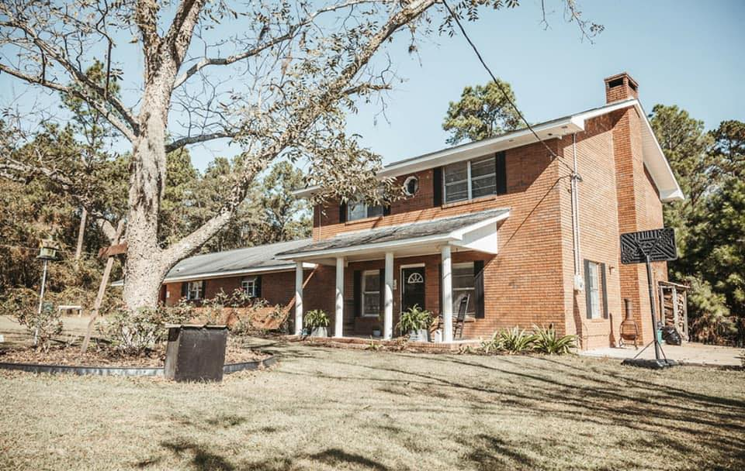  Promise of Hope Tattnall, Inc.  1091 Old Anderson Cemetery Road Glennville, GA 30427  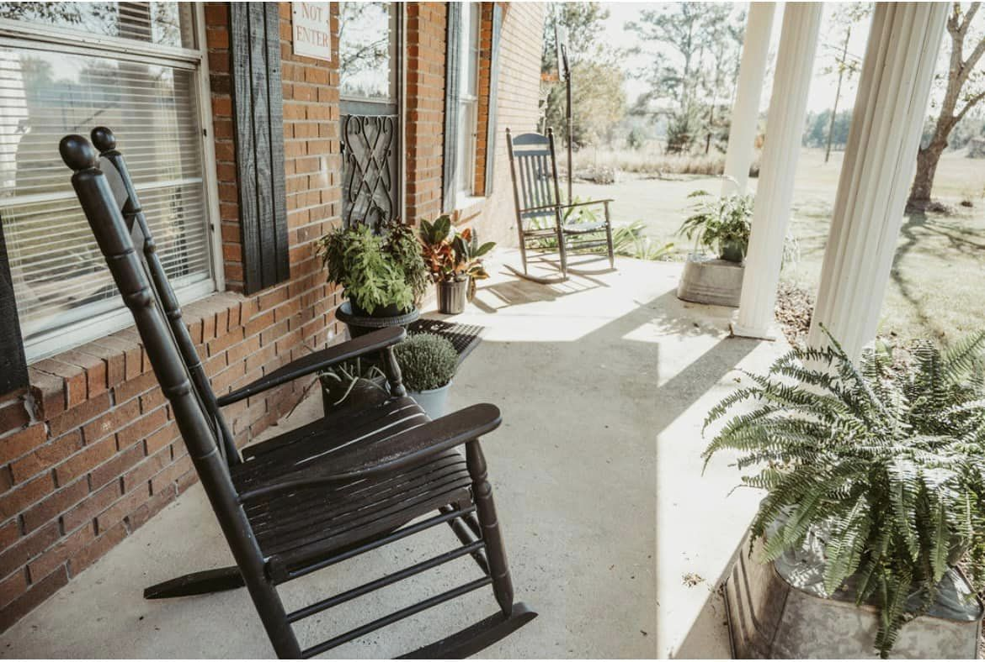  To present to women an understanding of Christ’s forgiveness and understanding through the study of God’s Holy Word and 12 Step Recovery Programs
   | 
  www.promiseofhopetattnallga.org
  mandy@promiseofhopetattnallga.org
  Promise of Hope Tattnall, Inc.  PO Box 485  Glennville, GA 30427 | Phone 912.654.1132  Fax 912.654.1139
  Promise of Hope Tattnall, Inc.
    - Helping women to overcome past obstacles, to develop improved relationships, and more importantly to develop their personal relationship with Jesus Christ

r
The Promise of Hope Tattnall System  Promise of Hope is a 12-month program, with evaluation for ¾ way services.  We have carefully planned the schedule so the needs of the residents are met in a manner that will allow them to be bridged back into society. We provide an environment where these sisters, daughters, wives, and mothers can begin to feel worthy and loved again. They are taught how to allow Jesus to be the ultimate authority in their lives. The foundation of the system is based on developing a personal relationship with Jesus. The education of addiction and recovery is broken down into a three-phase process. We are also a work program, with the residents going to work after the first 7 days to full time employment to offset program costs. |  | Who is Promise of Hope Tattnall, Inc.  Promise of Hope Tattnall serves as a faith-based long-term recovery residence for women. We offer yearly recovery programs for women over 18 years of age.  Your recovery process with us will include weekly church attendance on Sundays, consistent AA and NA 12-step programs, and fellowship with others in recovery. Classes will be provided during recovery, including subjects such as life skills, boundaries, education, insight meetings, and relapse prevention. Regular Bible study will be observed as well as several outside group activities.  Most important, we will do our best to provide a much-needed safe space for your recovery here at Promise of Hope Tattnall. Your recovery needs and your recovery pace will be heard, considered and recognized. Join us and take those precious first steps towards a life free from addiction and abuse.   |  | “An addiction recovery program that works for you. The Promise of Hope Tattnall System helps you live a life of freedom through faith.”    Our System:  - 12 Steps of Recovery  - Therapeutic Community  - Life Skills Meetings  - Serenity Bible  - Boundary Meetings  - AA/NA Meetings  - Devotions  - Church  - Residential Community  - Visitations and Outings
  
  Mandy Willis Hall, CACI
  CEO

